Workflow of Angular

The first clue that

angular.json –main

It is the file that consists of all the configurations and references of the application.
The build sections denote that the builder should start its execution from here
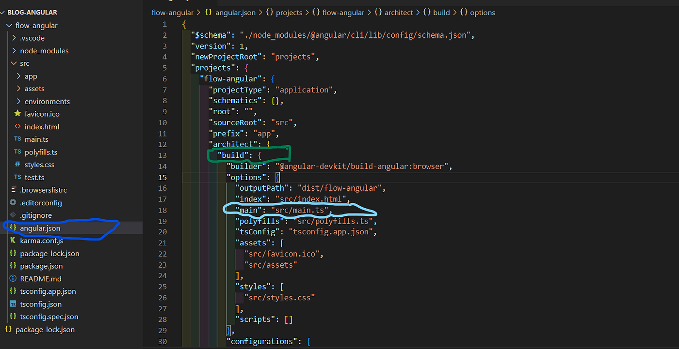

So , our next clue is main.ts
We can partition the main.ts file into two sections as below

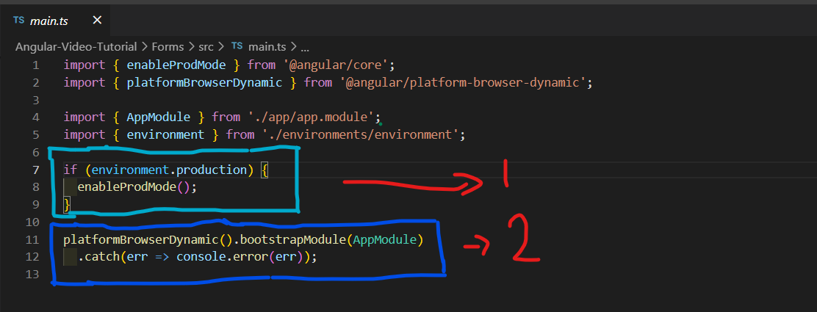
So, platformbrowserDynamic() is responsible for creating a platform (place)to render our application in the browser.
The bootstrapping the AppComponent which is imported from app.component.ts file. So the AppComponent gets loaded next. We can modify the project’s bootstrap component according to our needs.
<app-root></app-root> selector is used as an element to get the app component.

Our next clue is index.html .
index.html :
Yeah! it is available in our src folder. This is the main placeholder of our whole application.
But, however, the browser only knows the single index.html

